ARCHITECTURAL VISUAL DESIGN – EYE TRACKING ANALYSIS OF CHURCH INTERIORS CREATED USING ARTIFICIAL INTELLIGENCE

Wojciech KOCKI^{1,}*, Mariusz DZIEŃKOWSKI²

¹ Department of Contemporary Architecture, Faculty of Civil Engineering and Architecture, Lublin University of Technology, Nadbystrzycka 38D, 20-618 Lublin, Poland
² Department of Computer Science, Faculty of Electrical Engineering and Computer Science, Lublin University of Technology, Nadbystrzycka 38A, 20-618 Lublin, Poland

Abstract

The integration of artificial intelligence in scientific research offers novel opportunities and directions for exploration. In this context, an experiment was conducted to examine the application of eye-tracking technology and the indirect insights obtained through OpenAI. This study extends previous research on the design of altars in Catholic churches and their interior architecture. The interior of a church plays a crucial role in fostering the concentration and prayerful engagement of the faithful. Findings from the initial phase of the research were leveraged to design a subsequent experiment. In this phase, visualizations generated using OpenAI’s ChatGPT-4.0 were introduced based on predefined guidelines derived from design expertise and prior research outcomes. These guidelines encompassed aspects such as color schemes, architectural styles, and visualization parameters. This article presents the results of the eye-tracking study in this domain as well as providing a comprehensive description of the methodology and the role of artificial intelligence in the research process.

Keywords: Architecture; Visual design; Eye tracking; Altar; Visual analysis; OpenAI;
ChatGPT; Artificial Inteligence; AI

Introduction

To explore the potential applications of artificial intelligence (AI) in scientific research, an experiment was conducted that indirectly uutilized this technology. AI has demonstrated a positive impact across various fields, including scientific disciplines, by enhancing the quality of products, services, and research processes. However, it is essential to acknowledge that AI should not be employed to generate research results, compose scientific articles, interpret findings, or formulate research methodologies [1]. AI-based tools operate on pre-existing databases, meaning that their outputs and insights are derived from these sources. Given the continuous emergence of new information and research findings, it is crucial to ensure the timely updating of AI source databases to maintain the accuracy and relevance of generated data.
However, this process does not occur instantaneously; therefore, any research findings generated with the assistance of artificial intelligence must be rigorously verified and cross-referenced with traditionally established and reliable sources of knowledge [2]. Nonetheless, certain specific aspects of scientific research can benefit from AI support, potentially enhancing both experimental procedures and the reliability of obtained results. At its current level of advancement, artificial intelligence should be regarded as a supplementary research tool, applicable within clearly defined parameters [3]. Importantly, every scientific study represents an original and independent outcome of research efforts, rather than a mere AI-generated response. The experiment discussed in this article was conducted in accordance with this approach, utilizing AI in an indirect and controlled manner.

Experimental part

The primary objective of this research is to examine how interior design influences visual focus and to identify potential modifications that could enhance this effect. Architectural and design solutions typically stem from the knowledge, experience, and aesthetic sensibility of the architect. Often, these solutions are unique, conceived solely by their creator, and difficult for others to replicate.

Materials

The materials utilized in this research included findings from the initial phase of the study, AI-generated visualizations, an eye-tracking experiment involving several dozen participants, and data analysis through statistical summaries, tables, and charts.
Generating 12 visualizations using ChatGPT-4.0 required the formulation of highly specific guidelines to achieve the intended graphical representations. Similar visualizations could have been manually created using CAD architectural design software and graphic visualization tools. However, the integration of artificial intelligence introduces entirely new possibilities for exploring architectural interior design.
Below, in Fig. 1, three visualizations are shown as a response to the same descriptive guideline. As can be seen, artificial intelligence creates quite similar graphic visualizations, but in form and architecture the interiors of the churches differ quite significantly.

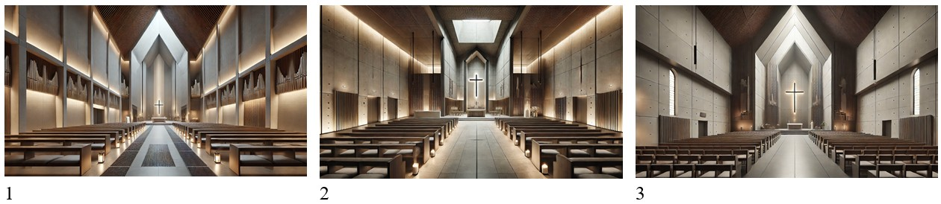
Fig. 1. Three (1, 2, 3) visualizations generated by ChatGPT 4.0, obtained on the basis of the same descriptive guideline, show significant differences in terms of interior architecture and perspective.

Results and discussion

Based on the results of the conducted eye-tracking experiment, the findings outlined below were obtained. Figures 7 through 18 present the heat maps generated for all 65 participants. Each illustration represents a negative result, indicating the areas of greatest visual interest observed by the participants [15]. From these areas, two regions exhibiting the highest levels of interest were selected for each visualization. For each of these areas, the parameters listed in Table 1 were subsequently determined.

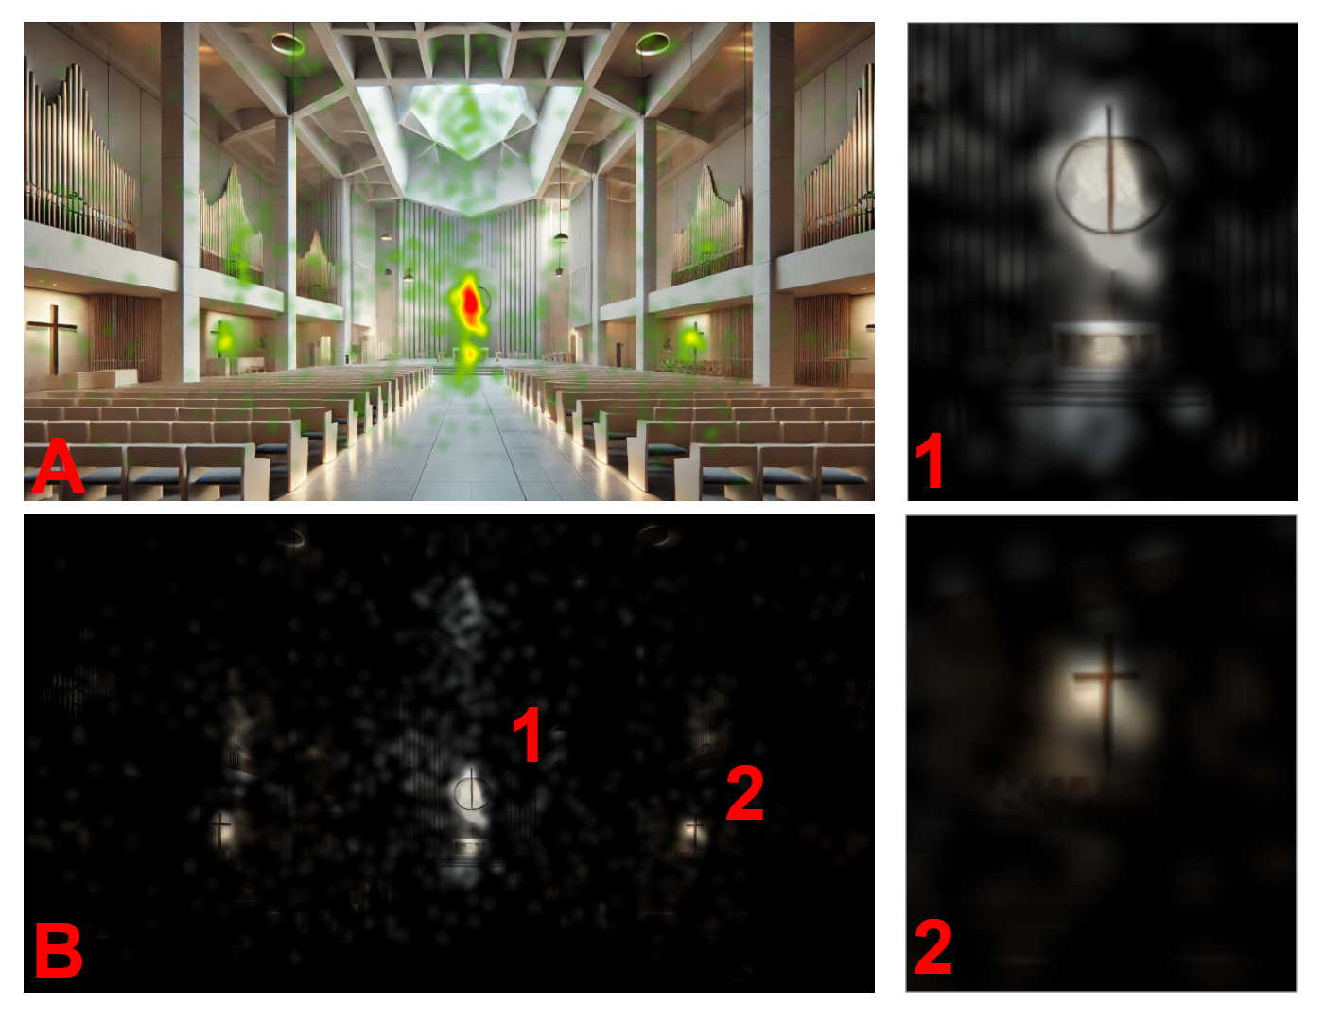
Fig. 7. Image number 1-modernist, A – results of heat map analysis, B – results of opacity analysis,
1 – first area of greatest interest, 2 – second area of greatest interest.

Table 1 represents the following criteria, which were used in the comparative analysis and comparison charts (Fig. 5-14):
- Image: ordinal number of the examined visualization,
- Spot: 1 - first place of greatest interest, 2 - second place of greatest interest,
- Position: location of the observed element, left, right, centre, top, bottom,
- Subject: silhouette, ornament, architectural accent, religious symbol, window,
- IA: maximum fixations count per unit area (IA expressed in fpa),
- TTFF: mean time to the first fixation per area of interest,
- FD: mean fixation duration in AOI,
- PF: the percentage of participants that fixated at least once within an AOI (in %).

Table 1. Table of various values analyzed in the study in terms of individual images and marked spots. Significant exceedances are marked in red, including for IA over 20, for TTFF and FD over 2.5, and for PF over 0.8.

1 | Image | Spot | Position | Subject | IA  [fpa] | TTFF  [s] | FD  [s] | PF  [%]
2 | 1 | 1 | Centre | Architectural accent | 24 | 0.75 | 0.27 | 0.88
3 | 1 | 2 | Right | Religious symbol | 10 | 2.98 | 0.27 | 0.51
4 | Total | 2
5 | 2 | 1 | Centre | Religious symbol | 12 | 0.84 | 0.26 | 0.83
6 | 2 | 2 | Left | Silhouette | 10 | 2.30 | 0.28 | 0.68
7 | Total | 2
8 | 3 | 1 | Centre | Architectural accent | 16 | 1.17 | 0.25 | 0.88
9 | 3 | 2 | Top | Window | 11 | 2.41 | 0.26 | 0.46
10 | Total | 2
11 | 4 | 1 | Centre | Architectural accent | 15 | 0.87 | 0.27 | 0.83
12 | 4 | 2 | Left | Silhouette | 10 | 2.41 | 0.24 | 0.52
13 | Total | 2

Conclusions

The results obtained from the experiment highlight the significance of the interior's character and its impact on the dynamics of eye movement. Human vision is in a constant state of analysis, continuously processing visual information [16]. This implies that the dynamics of vision are exceptionally high.
In conclusion, it can be asserted that when utilized within a defined scope and for specific purposes, artificial intelligence tools can significantly contribute to the acquisition of meaningful and valuable research results [24]. It is also important to recognize that the integration of architectural design with eye-tracking technology holds the potential to yield groundbreaking research outcomes, with tangible implications for the design of architectural spaces.

Acknowledgements/Funding

We would like to thank to …

References

[1] Y. Liu, Z. Zhou, and Y. Xu, “Design element preferences in public facilities: An eye tracking study,” Land, vol. 12, no. 7, pp. 1–17, 2023, doi: 10.3390/land12071411.
[2] K. Rayner, “Eye movements and attention in reading, scene perception, and visual search,” Quarterly Journal of Experimental Psychology, vol. 62, pp. 1457–1506, 2009, doi: 10.1080/17470210902816461.
[3] S. K. Mannan, K. H. Ruddock, and D. S. Wooding, “Automatic control of saccadic eye movements made in visual inspection of briefly presented 2-D images,” Spatial Vision, vol. 9, no. 3, pp. 363–386, 1995, doi: 10.1163/156856895X00052.
[4] W. Krauze and M. Motak, “Neurosciences in architecture: Applied research and its potential in architectural design,” Teka Komisji Urbanistyki i Architektury PAN w Krakowie, vol. 50, pp. 330–356, 2022, doi: 10.24425/tkuia.2022.144856.
[5] H. J. Rosas, A. Sussman, A. C. Sekely, and A. A. Lavdas, “Using eye tracking to reveal responses to the built environment and its constituents,” Applied Sciences, vol. 13, no. 21, pp. 3–25, 2023, doi: 10.3390/app132112071.
[6] P. Huddleston, B. K. Behe, S. Minahan, and R. T. Fernandez, “Seeking attention: An eye-tracking study of in-store merchandise displays,” International Journal of Retail & Distribution Management, vol. 43, no. 6, pp. 561–574, 2015, doi: 10.1108/IJRDM-06-2013-0120.
[7] P. Wang, W. Song, J. Zhou, Y. Tan, and H. Wang, “AI-based environmental color system in achieving sustainable urban development,” Systems, vol. 11, no. 3, pp. 1–16, 2023, doi: 10.3390/systems11030135.
[8] W. Kocki and M. Dzieńkowski, “Architectural visual design—Eye-tracking analysis of church altars: A case study,” International Journal of Conservation Science, vol. 15, no. 3, pp. 1346–1347, 2024, doi: 10.36868/IJCS.2024.03.12.
[9] M. F. Islam et al., “Involution fused convolution for classifying eye-tracking patterns of children with autism spectrum disorder,” Engineering Applications of Artificial Intelligence, vol. 139, pp. 14–15, 2024, doi: 10.1016/j.engappai.2024.109475.
[10] M. Lisińska-Kuśnierz and M. Krupa, “Suitability of eye tracking in assessing the visual perception of architecture—A case study,” Buildings, vol. 10, no. 2, pp. 1–23, 2020, doi: 10.3390/buildings10020020.
[11] E. J. Kim and Y. Kang, “Analyzing image recognition characteristics in landscape architecture,” Frontiers of Architectural Research, vol. 14, no. 3, pp. 797–811, 2024, doi: 10.1016/j.foar.2024.09.010.
[12] G. R. Loftus, “Picture perception: Effects of luminance on available information,” Journal of Experimental Psychology: General, vol. 114, no. 3, pp. 342–356, 1985, doi: 10.1037/0096-3445.114.3.342.
[13] G. Lio, R. Fadda, G. Doneddu, J. R. Duhamel, and A. Sirigu, “Digit-tracking as a new tactile interface for visual perception analysis,” Nature Communications, vol. 10, pp. 1–13, 2019, doi: 10.1038/s41467-019-13285-0.
[14] A. Bojko, “Informative or misleading? Heatmaps deconstructed,” in *Human–Computer Interaction. New Trends (HCI 2009)*, Lecture Notes in Computer Science, vol. 5610, Berlin, Germany: Springer, 2009, doi: 10.1007/978-3-642-02574-7_4.
[15] R. J. K. Jacob and K. S. Karn, “Eye tracking in human-computer interaction and usability research: Ready to deliver the promises,” in The Mind’s Eye, Amsterdam, Netherlands: Elsevier, 2003, pp. 573–605, doi: 10.1016/B978-044451020-4/50031-1.
[16] J. B. Hollander, A. Sussman, P. Lowitt, N. Angus, and M. Situ, “Eye-tracking emulation software: A promising urban design tool,” Architecture Science Review, vol. 64, no. 4, pp. 383–393, 2021, doi: 10.1080/00038628.2021.1929055.
[17] Z. Bylinskii et al., “Eye fixation metrics for large-scale evaluation and comparison of information visualizations,” in Eye Tracking and Visualization, Cham, Switzerland: Springer, 2017, pp. 235–255, doi: 10.1007/978-3-319-47024-5_14.
[18] S. Erslan, “Eye tracking scanpath analysis techniques on web pages: A survey, evaluation and comparison,” Journal of Eye Movement Research, vol. 9, no. 1, pp. 1–19, 2015, doi: 10.16910/jemr.9.1.2.
[19] Tobii AB, User Manual—Tobii Studio, ver. 3.2 Rev. A. Stockholm, Sweden, 2012.
[20] B. Wąsikowska, “Eye tracking w badaniach marketingowych,” Studia Informatica, vol. 36, pp. 177–192, 2015, doi: 10.18276/si.2015.36-13.
[21] K. Rayner, “Eye movements in reading and information processing,” Psychological Bulletin, vol. 85, pp. 618–660, 1978, doi: 10.1037/0033-2909.85.3.618.
[22] W. Tuszyńska-Bogucka et al., “The effects of interior design on wellness—Eye tracking analysis in determining emotional experience of architectural space,” Annals of Agricultural and Environmental Medicine, vol. 27, no. 1, pp. 113–122, 2020, doi: 10.26444/aaem/106233.
[23] W. Einhäuser, C. Atzert, and A. Nuthmann, “Fixation durations in natural scene viewing are guided by peripheral scene content,” Journal of Vision, vol. 20, no. 4, pp. 1–15, 2020, doi: 10.1167/jov.20.4.15.
[24] K. Panetta et al., “Software architecture for automating cognitive science eye-tracking data analysis and object annotation,” IEEE Transactions on Human-Machine Systems, vol. 49, no. 3, pp. 268–277, 2019, doi: 10.1109/THMS.2019.2892919.

______________________________________

Received: March 27, 2025
Accepted: October 30, 2025

* Corresponding author: w.kocki@pollub.pl

